**PSEUDECODE PROGRAM MENU KASIR SEDERHANA**

# membuat program menu

# fungsi login

def fungsiLogin():

print("+=============================+")

print("|/////HALAMAN LOGIN KASIR/////|")

print("+=============================+")

username = input("Username : ")

password = input("Password : ")

if username == "admin" and password == "adminpass":

print("Login berhasil...\n")

fungsiMenu()

else:

print("Login gagal coba lagi..")

fungsiLogin()

# fungsi menu

def fungsiMenu():

print("""

+==================================+

|/////MAIN MENU APLIKASI KASIR/////|

+==================================+

| Selamat datang di aplikasi kasir |

+----------------------------------+

| Menu aplikasi |

| 1. Program kasir |

| 2. Exit program |

+----------------------------------+

""")

# input pilihan

pilihan = input("pilih menu : ")

# pilihan menu

if pilihan == "1":

fungsiKasir()

else:

print("program exit")

exit()

# fungsi kasir

def fungsiKasir():

print("""

+===================================+

|///////////////////////////////////|

|////PT SAHABAT PANGAN SEJAHTERA////|

|///////////////////////////////////|

+===================================+

| Nama Barang | Kode | Harga |

+----------------+--------+---------+

| Cireng | CRG | 10000 |

| Nuget | NGT | 15000 |

| Bakso Ayam | BSA | 15000 |

| Bakso Sapi | BSS | 20000 |

| Pempek | PPK | 10000 |

+===================================+

""")

pesan = str(input("Kode Makanan (CRG/NGT/BSA/BSS/PPK) : "))

jumlahpesan = int(input("Jumlah Beli : "))

if pesan == "CRG":

listnama = "Cireng"

harga = (10000 * jumlahpesan)

if jumlahpesan >= 10:

diskon = int(harga * 0.2)

totalharga = int(harga - diskon)

else:

diskon =(0)

totalharga = int(harga)

elif pesan == "NGT":

listnama = "Nuget"

harga = (15000 * jumlahpesan)

if jumlahpesan >= 10:

diskon = int(harga * 0.2)

totalharga = int(harga - diskon)

else:

diskon =(0)

totalharga = int(harga)

elif pesan == "BSA":

listnama = "Baso Ayam"

harga = (15000 * jumlahpesan)

if jumlahpesan >= 10:

diskon = int(harga * 0.2)

totalharga = int(harga - diskon)

else:

diskon =(0)

totalharga = int(harga)

elif pesan == "BSS":

listnama = "Baso Sapi"

harga = (20000 * jumlahpesan)

if jumlahpesan >= 10:

diskon = int(harga * 0.2)

totalharga = int(harga - diskon)

else:

diskon =(0)

totalharga = int(harga)

elif pesan == "PPK":

listnama = "Pempek"

harga = (10000 * jumlahpesan)

if jumlahpesan >= 10:

diskon = int(harga * 0.2)

totalharga = int(harga - diskon)

else:

diskon =(0)

totalharga = int(harga)

else:

listnama = "-"

harga = "-"

diskon = "-"

totalharga = "-"

print("""

+---------------------------------+

|/////////STRUK PEMBELIAN/////////|

+---------------------------------+

Menu : {}

Jumlah Pesan : {}

Harga : {}

Diskon : {}

+---------------------------------+

Jumlah Bayar : {}

+---------------------------------+

""".format(listnama, jumlahpesan,

harga, diskon, totalharga))

ulangKasir()

# ulang kasir

def ulangKasir():

counter = input("Belanja lagi ? (y/t) : ")

if counter == "y":

fungsiKasir()

elif counter == "t":

tanya()

else:

print("Input program salah! harap ulangi.")

# fungsi tanya

def tanya():

tanya = input("Kembali ke menu..? (y/t)")

if tanya == "y":

fungsiMenu()

elif tanya == "t":

exit()

else:

print("Input salah")

print("Masukkan input dengan benar")

# main program

if _name=="main_":

fungsiLogin()

**FLOWCHART PROGRAM MENU KASIR SEDERHANA**

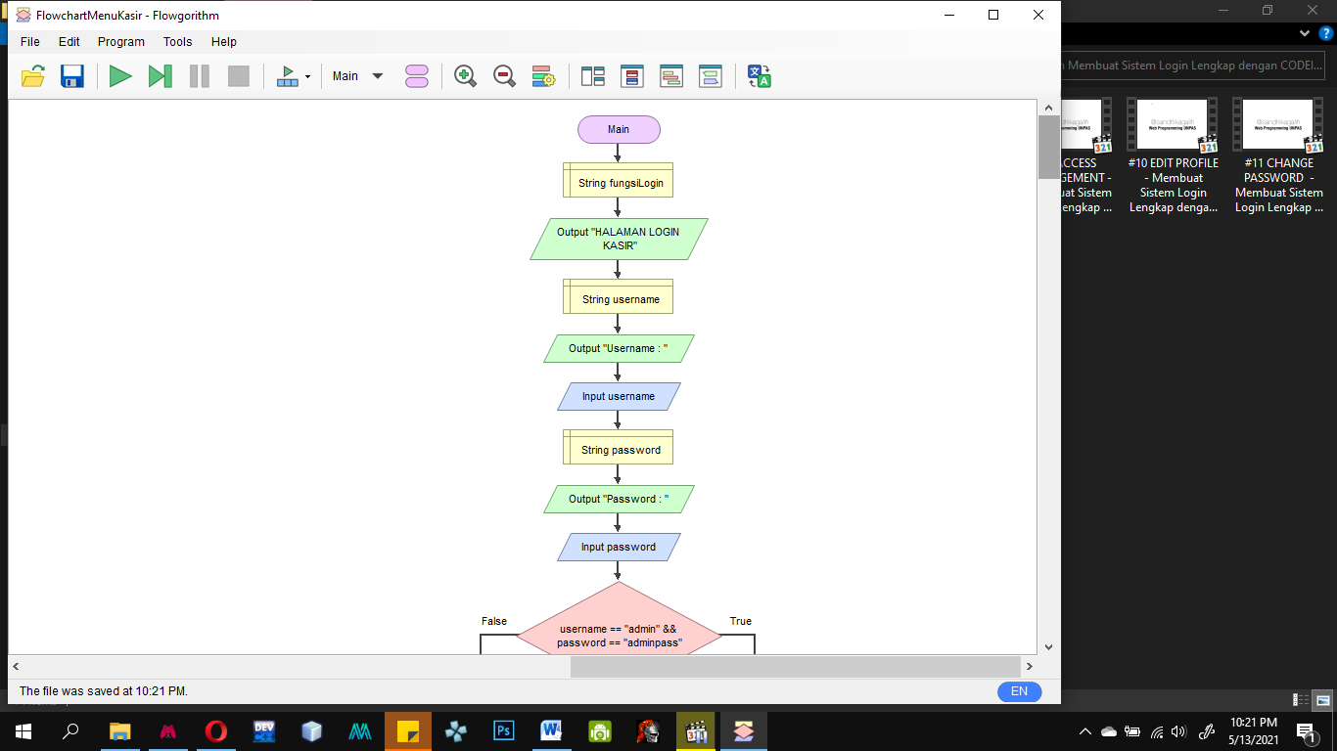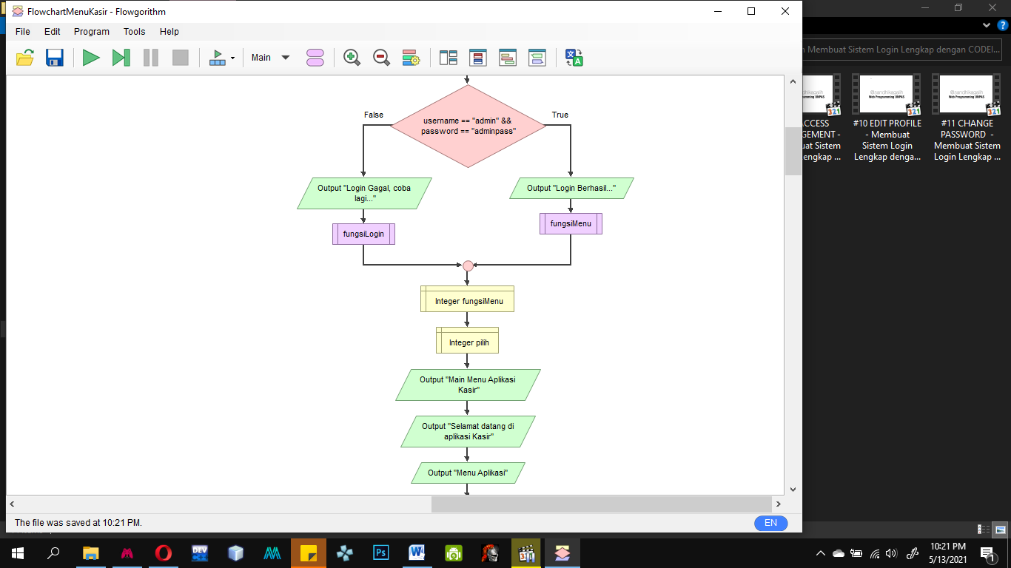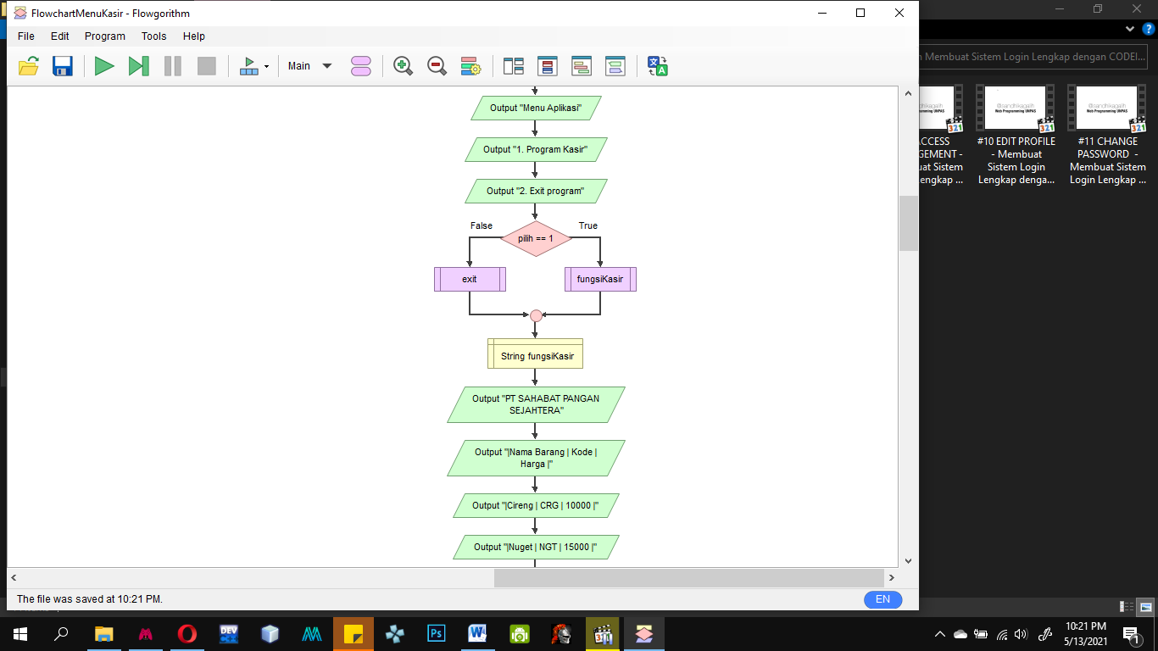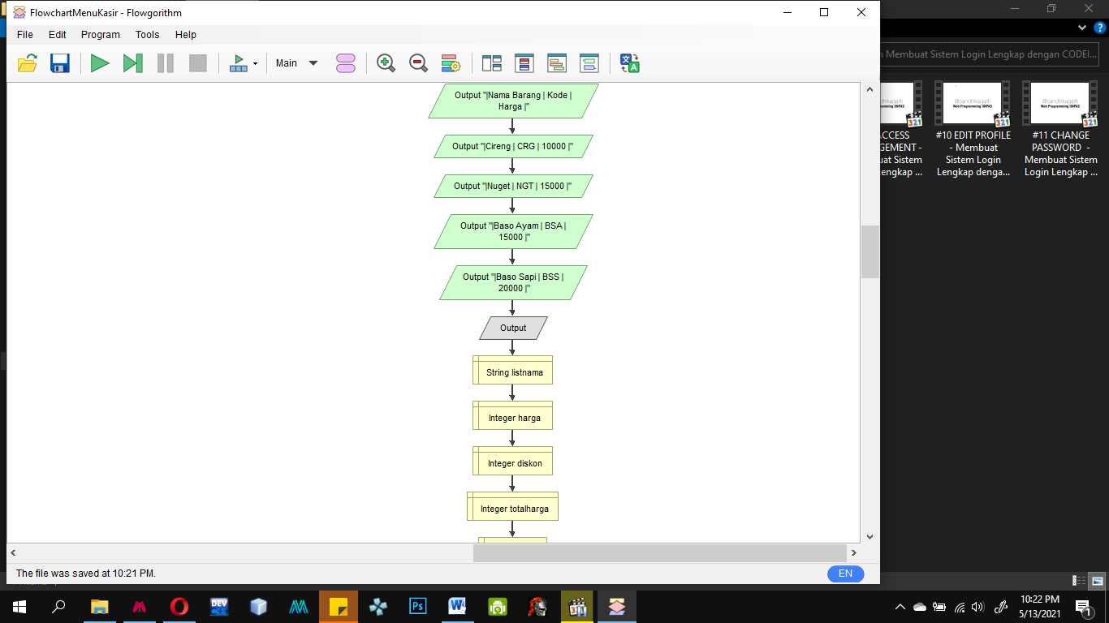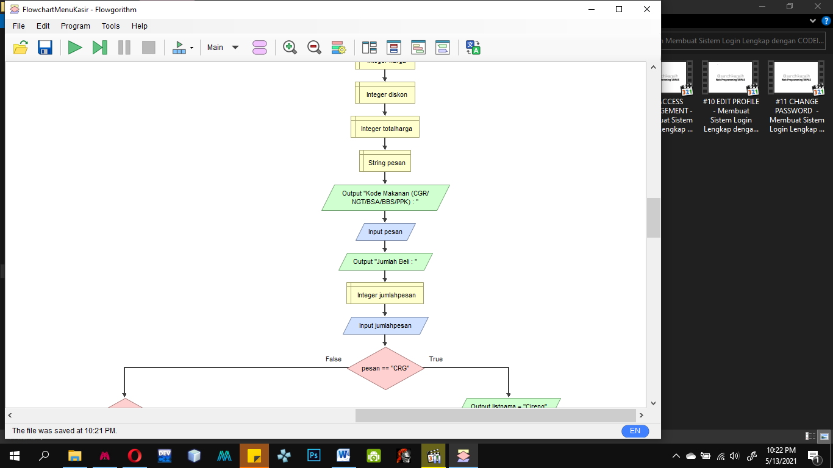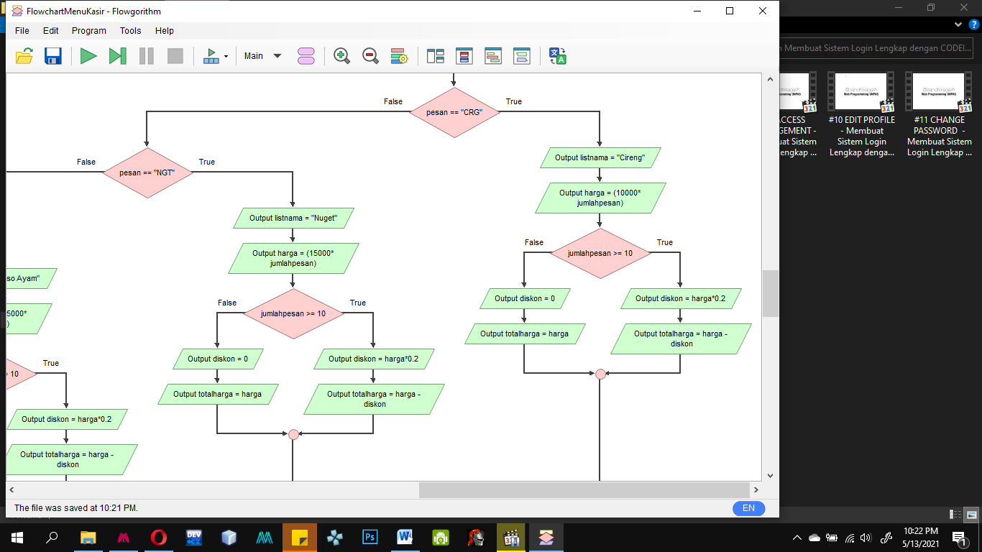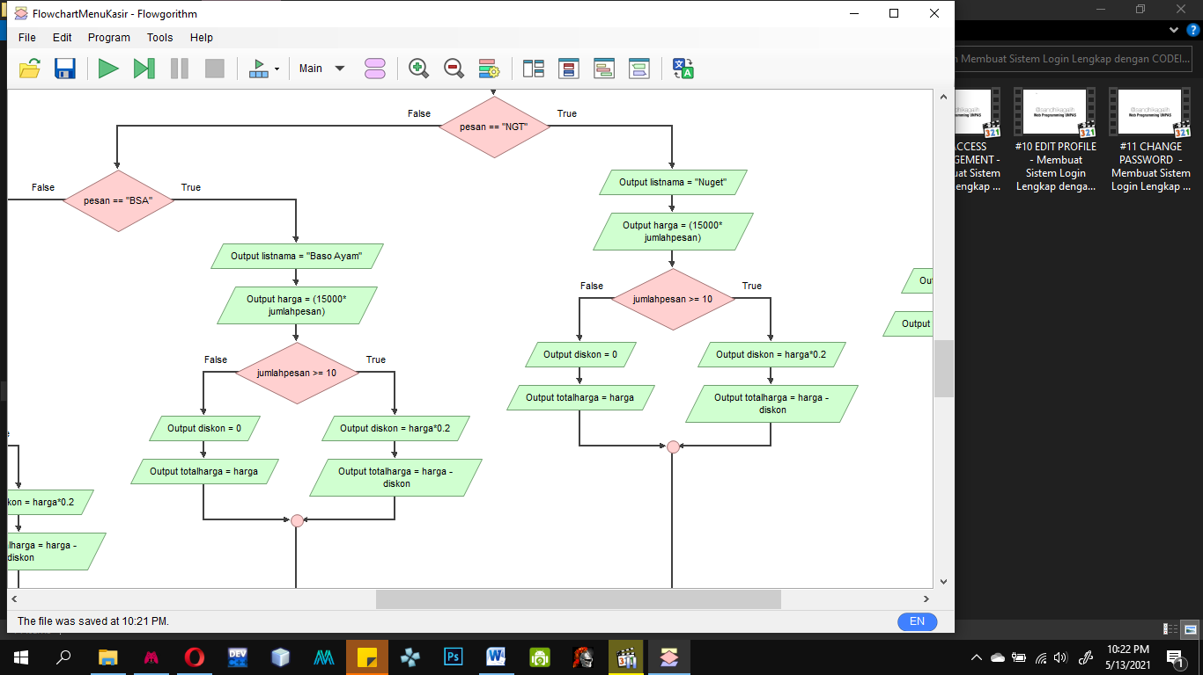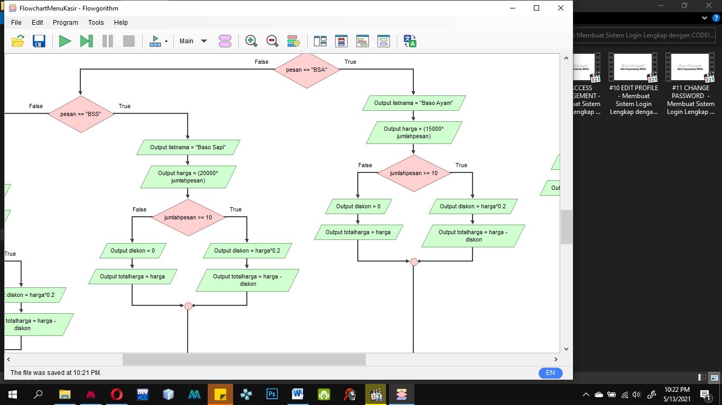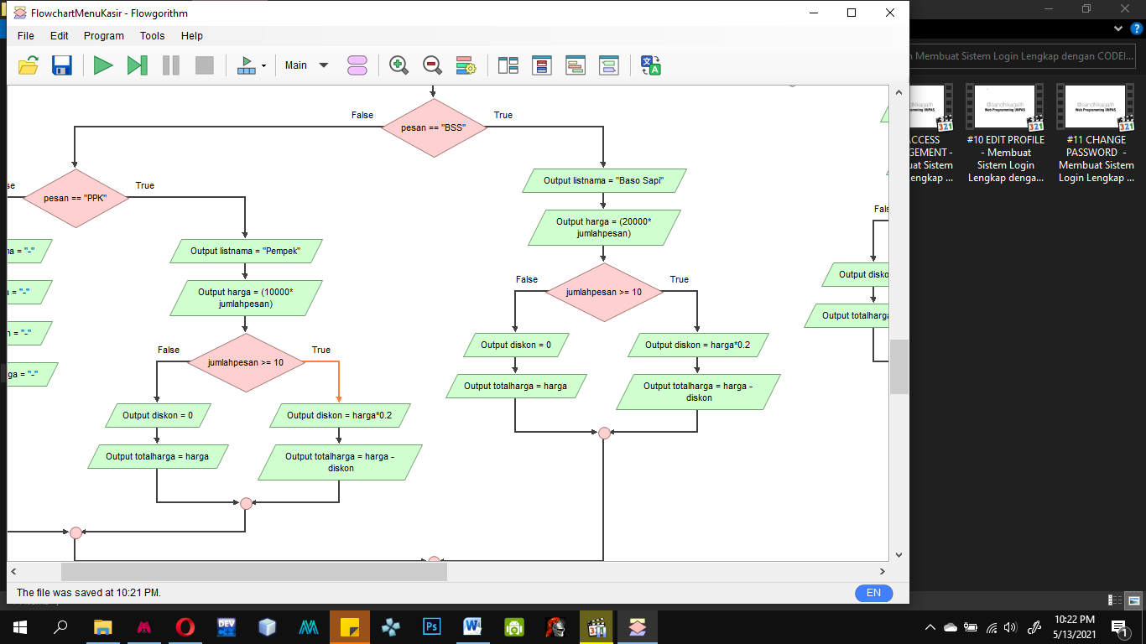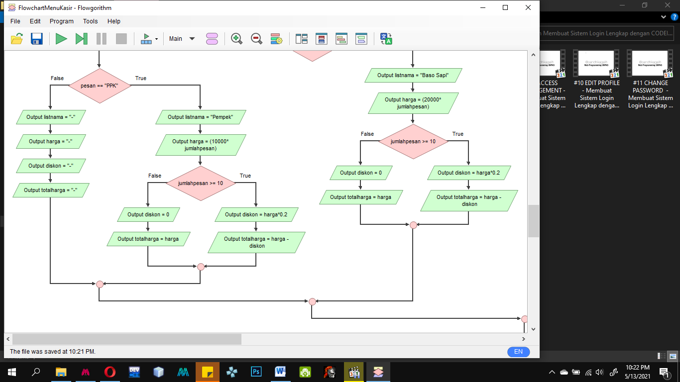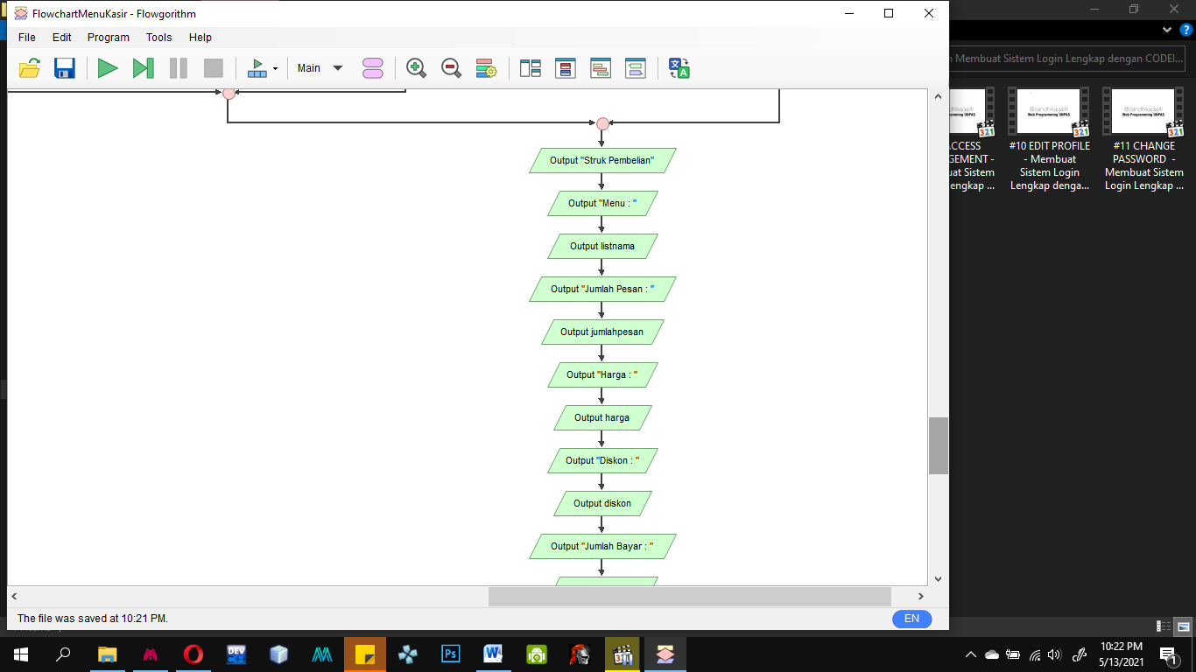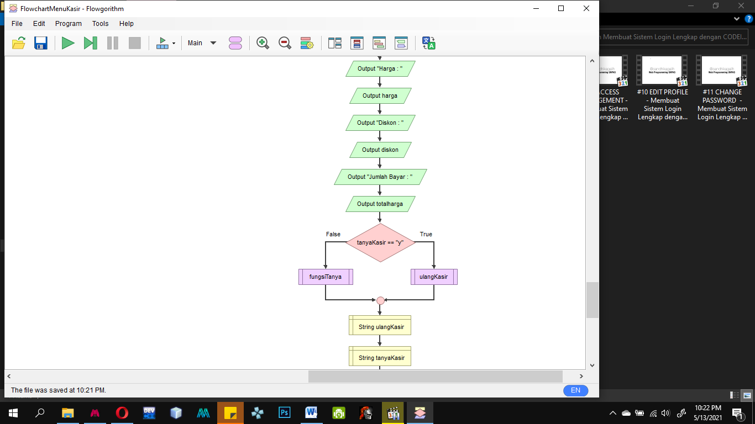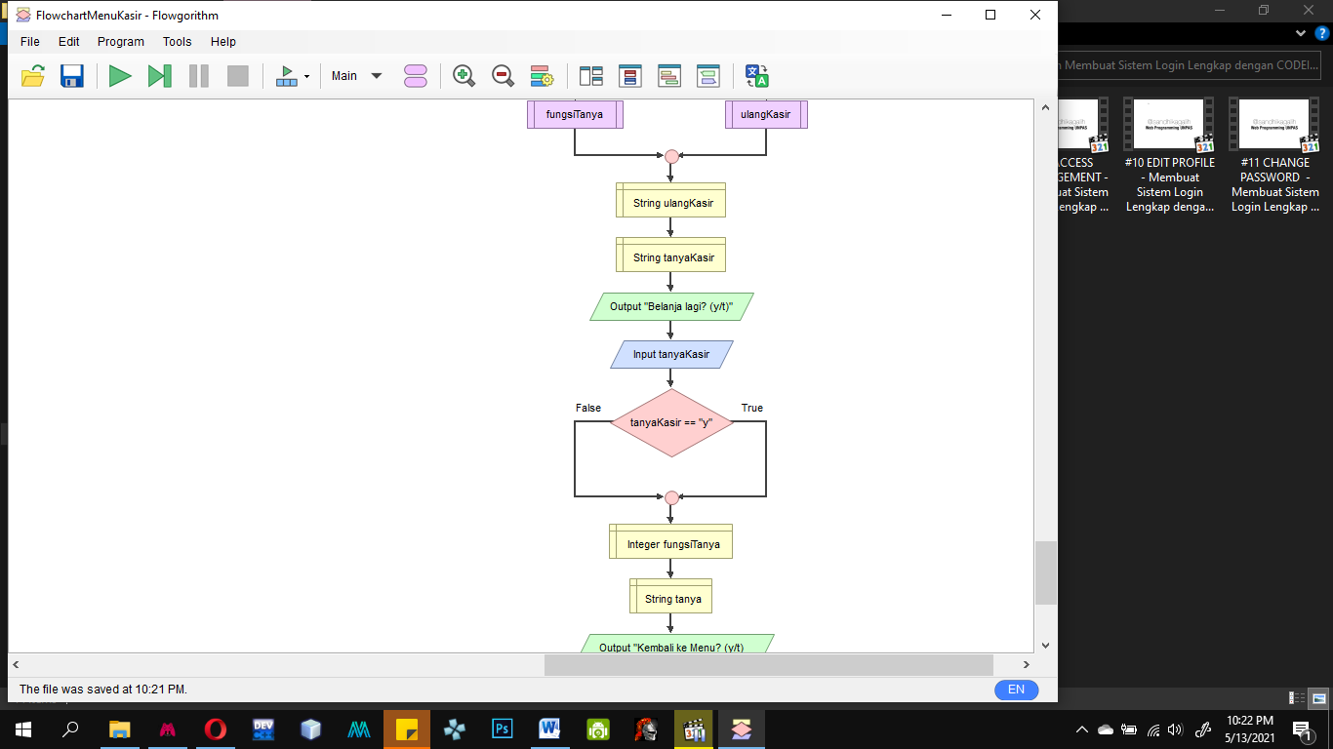

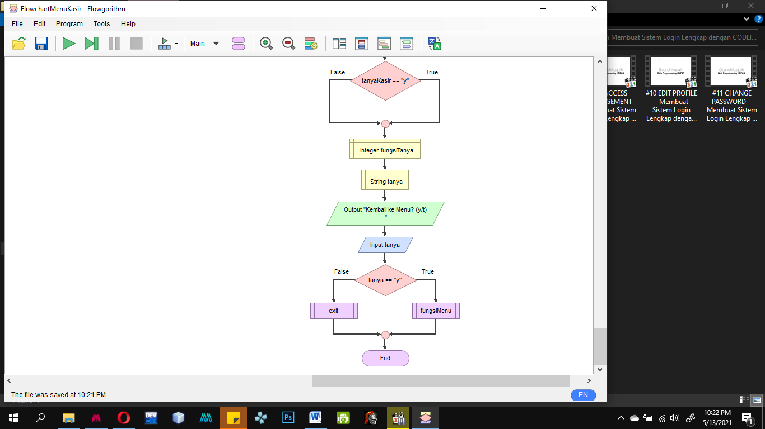

**Tampak dari Jauh**